**REACT JS MINI PROJECT (CAPSTONE PROJECT)**

**IKEA Store Website**

**Documentation**

**Technologies To Be Used:**

HTML, CSS, React.js, Node, Bootstrap, JSON Server, Redux, Axios, **(Deployment if possible).**

**Project Overview:**

This project works in the manner of a fully functional e commerce app where we have certain features:

1. **Pages (With Routes) And Components:** Home page, About Page, Contact Page, Login PageProducts Page, Products By Category, CRUD Page, Shopping Cart Page, Final Order Page, Admin Page, Customer Page.

**Modules Used:**

1. **Admin:** CRUD Process on Products, Admin Module is secured and we need to perform admin activities. Admin route should be secured**.**
2. **Customer:** View Products, View Products By Category, Add or Remove a product, see a product’s details, checkout.
3. **Shopping Cart Module:** Display all the products in cart, show grand total of all the products, customer can remove a product and when all the additions are done on the cart, customer can proceed for the checkout.

**PAGES AND COMPONENTS:**

**HOME PAGE:**

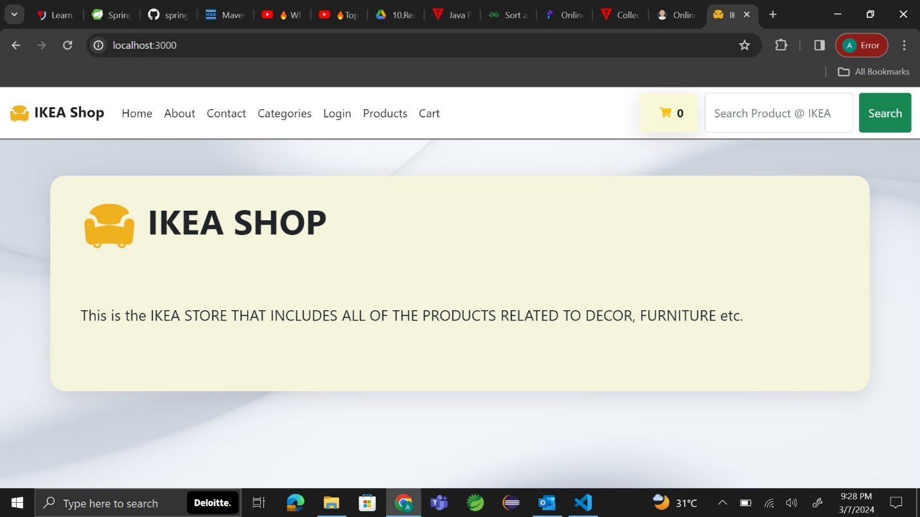

**ABOUT PAGE**:

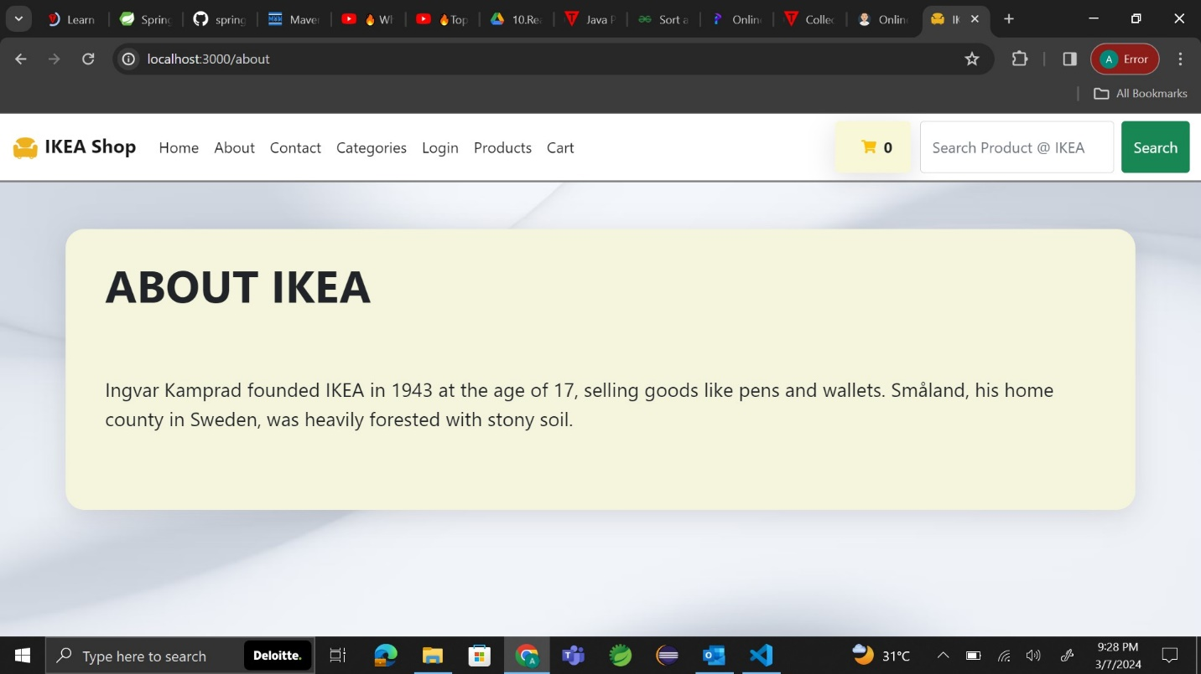

**CONTACT US:**

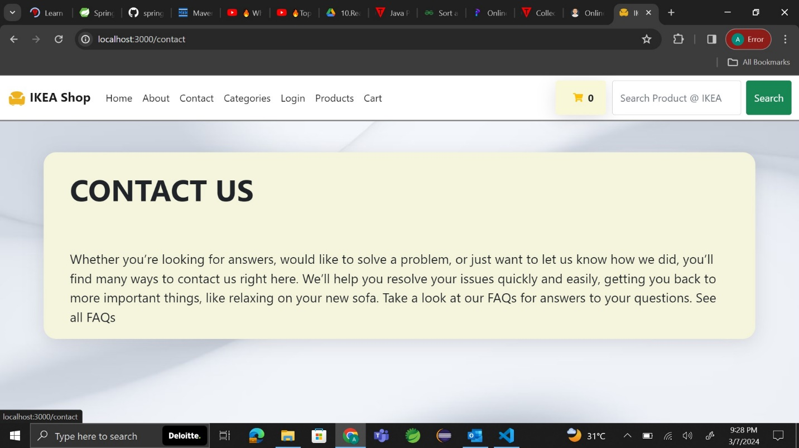

**CATEGORIES OF PRODUCTS:**

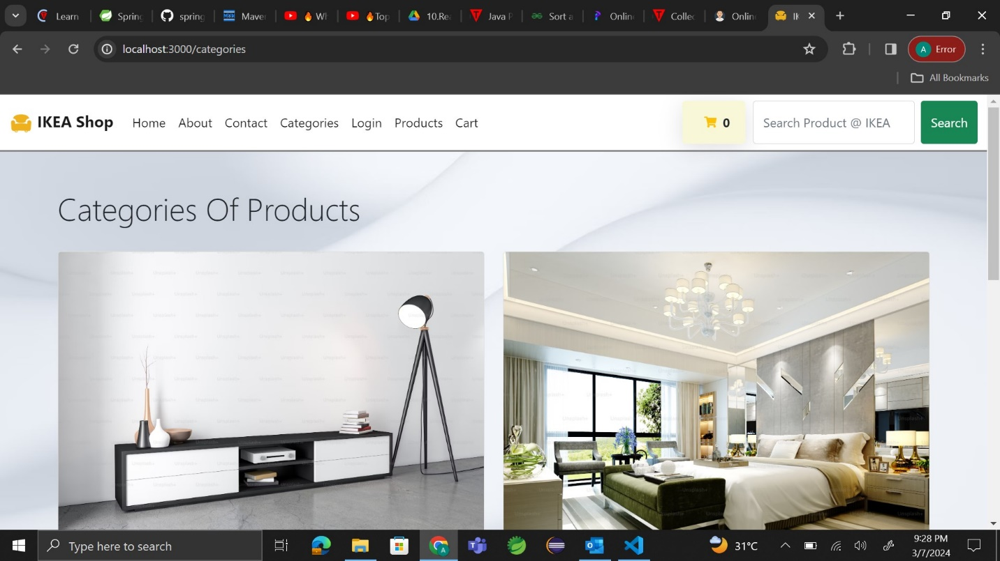

**ADMIN LOGIN:**

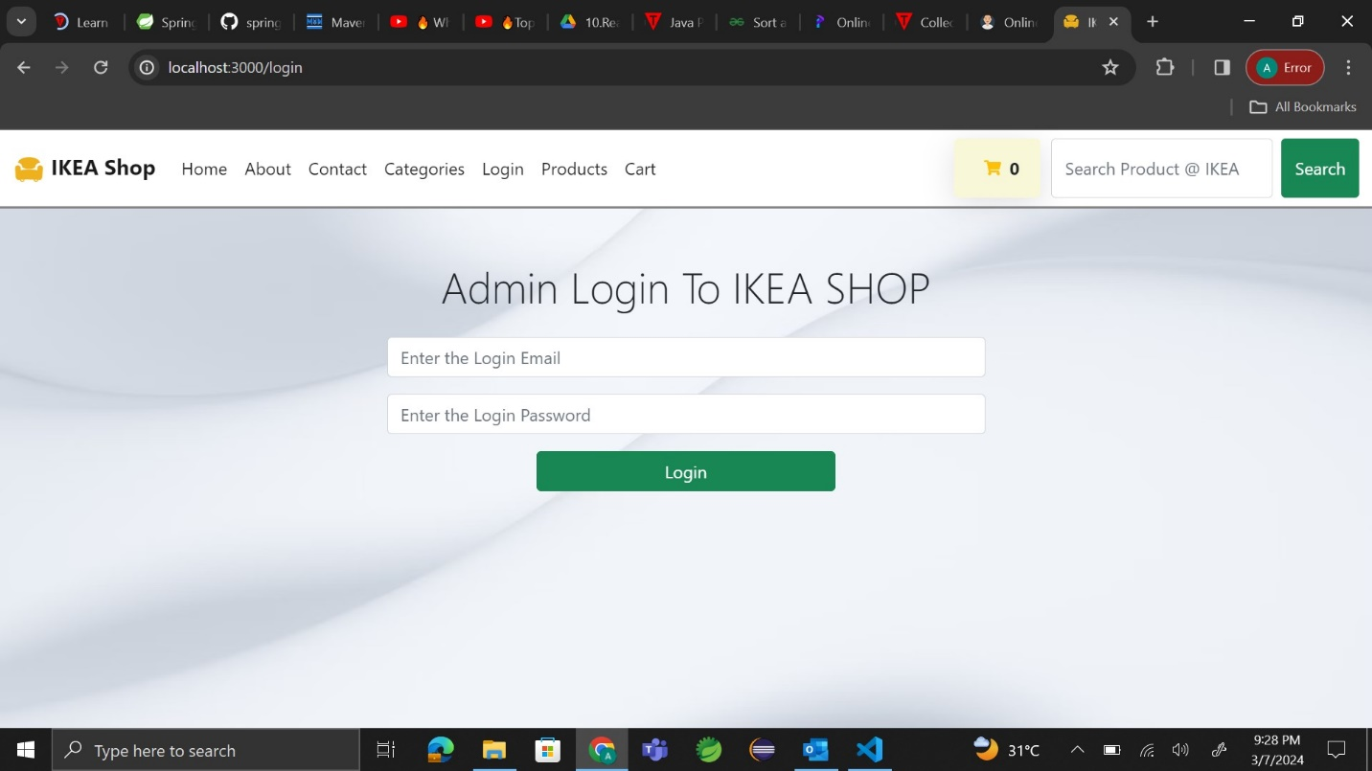

**PRODUCTS LIST:**

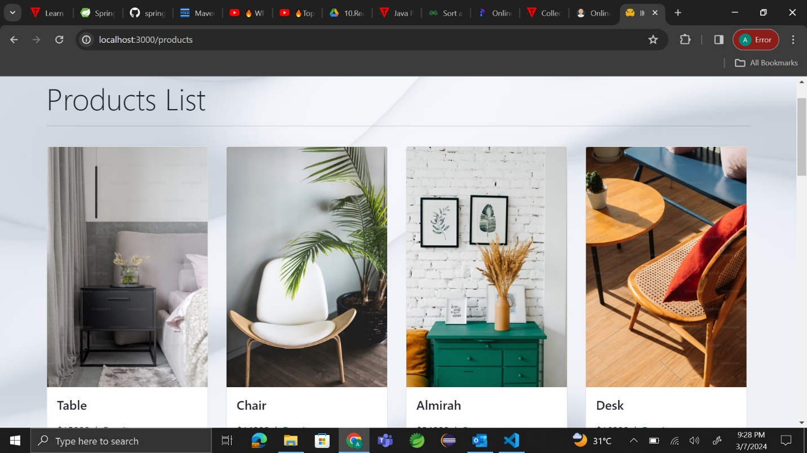

**ADMIN PANEL:**

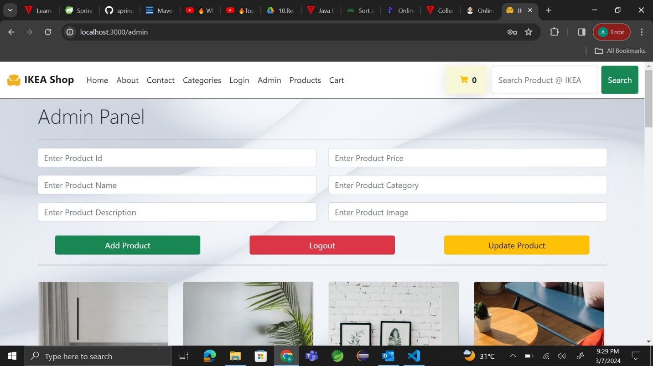

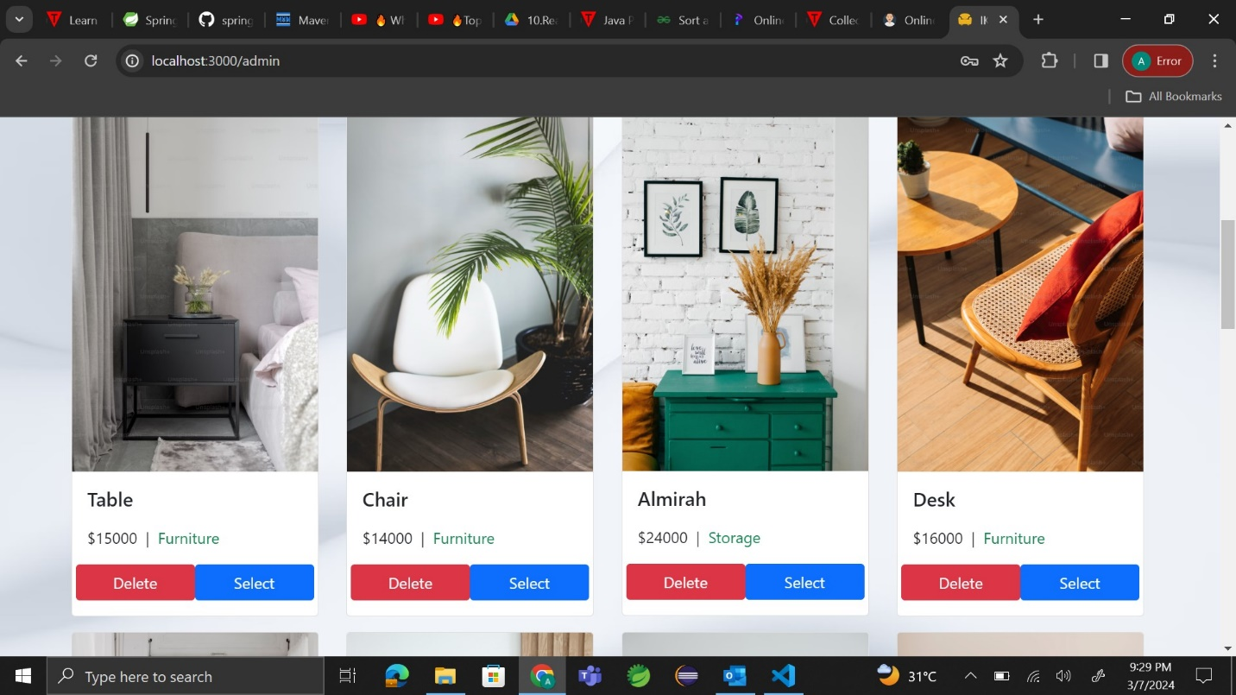

**CART DETAILS:**

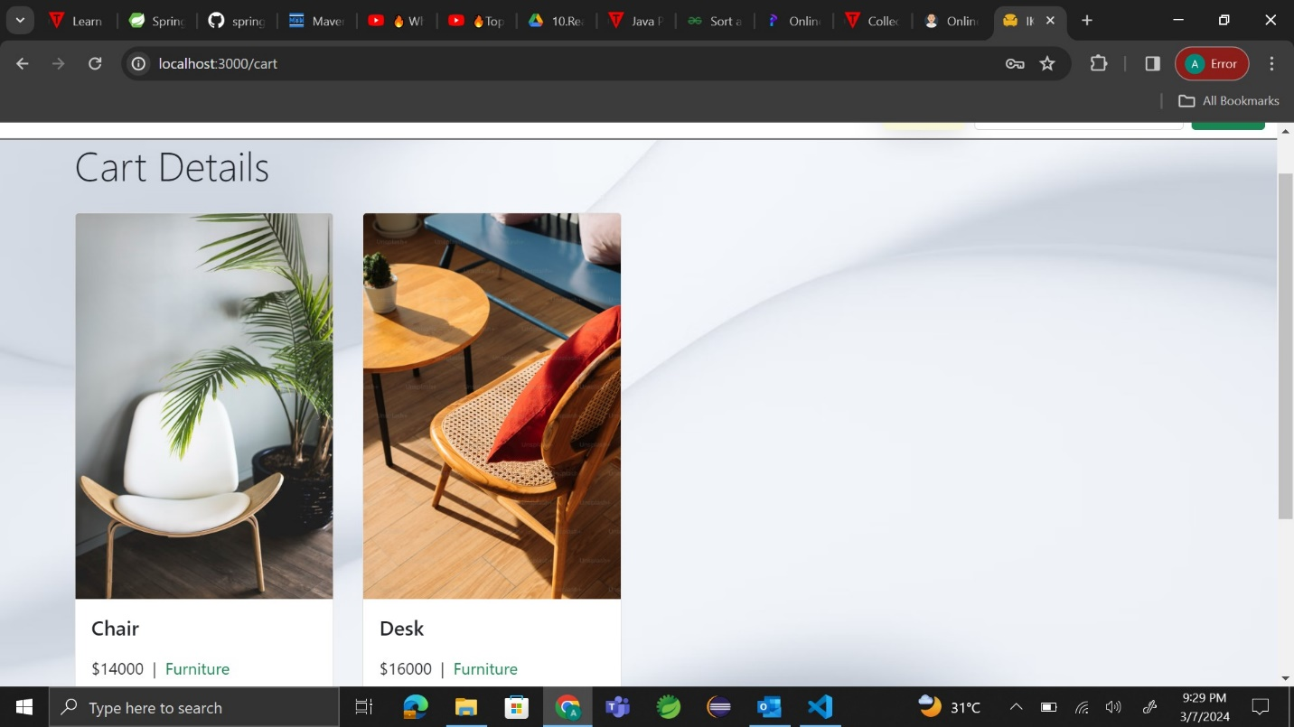

**CHECKOUT ORDER:**

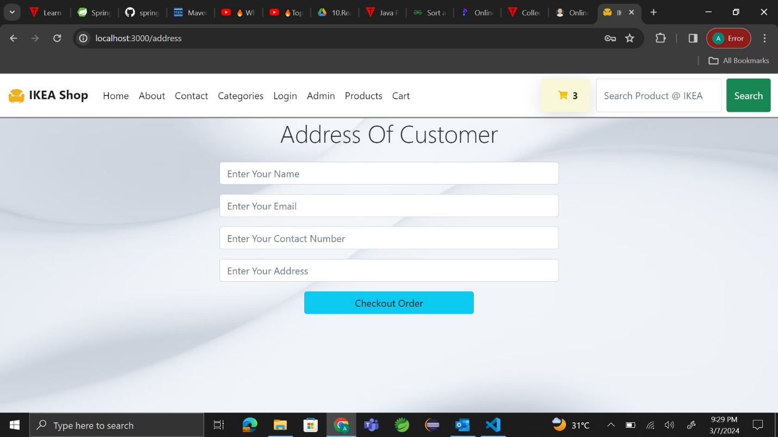

**FINAL SCREEN:**

